PO Box 4922, Eureka, CA 95502
(707) 445-3166
www.foodforpeople.org

February 9, 2024

Dear Friends,
Here at Food for People, Food Bank for Humboldt County, we have stepped up our work to make sure seniors, children, and families have a place to turn when ends don’t meet, and ensure no one in our community goes hungry. Your help is especially important now, as we meet growing needs across Humboldt County.
Today, more of our neighbors are seeking food assistance than ever in our 44 year history. This winter, the number of seniors and families coming to our pantries and distributions has grown by 30%, as prices of food and essential needs stretches budgets. Overall, the number of people our programs serve has jumped from 16,000 a month to 21,000 each month. We have been working hard to meet this need and ensure that anyone experiencing the negative effects of hunger and food insecurity have a place to turn – and you can help!
Your sponsorship donation will directly fund Food for People’s work to address hunger in Humboldt County. As a thank you for your sponsorship, we will recognize your partnership all year long in our media, in-person events and other creative ways. The attached menu lists all of our sponsorship and recognition levels.
Thank you for being part of addressing hunger in Humboldt County! We are looking forward to another year of working with you to help others.
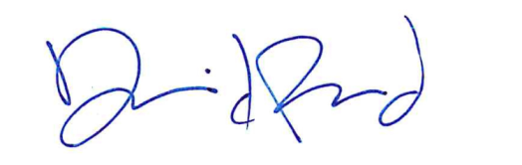
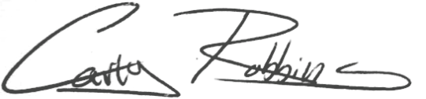
Carly Robbins, Executive Director  (707) 445-3166 ext. 302 | David Reed, Development Director  (707) 445-3166 ext. 306

Business Sponsorship Levels
Your business or organization’s annual sponsorship donation directly funds Food for People’s work to address hunger in Humboldt County. Your contribution furthers the reach of our programs and it brings your company or organization recognition in the community all year long. These sponsor levels are suggested, but we are happy to work with you to tailor a level and package of recognition especially for you.

Gold $10,000+
- Recognition
- Special Events ‐ be recognized at special events during a 12‐month period
- Swag ‐ logo on 100 Food for People t‐shirts
- Banner – your 24” logo will be front and center on our sponsor banner
Have your own? We will prominently display it at Food for People events!
- Newsletter ‐ logo in Food for People’s quarterly newsletters
- Media – Be recognized as a Food for People sponsor in our holiday advertisements (TV & print)
- Social Media Recognition – Quarterly social media posts recognizing you as a sponsor
- Website ‐ name and/or logo on Food for People website for 12 months
- Decal ‐ Food for People decal for your business to display

Silver $5,000
- Recognition
- Banner – your 12“ logo will be appear on our sponsor banner
- Newsletter ‐ logo in Food for People’s quarterly newsletter biannually
- Media – Be recognized as a Food for People sponsor in our holiday advertisements (TV & print)
- Social Media Recognition – Biannual social media posts recognizing you as a sponsor
- Website ‐ logo on Food for People website for 6 months
- Decal ‐ Food for People decal for your business to display
Bronze $1,000
- Recognition
- Banner – your 6“ logo will appear on our sponsor banner
- Newsletter – logo in at least one Food for People quarterly newsletter
- Social Media Recognition – Individual social media posts recognizing you as a sponsor
- Media – Be recognized as a Food for People sponsor in our holiday advertisements (TV & print)
- Website ‐ logo on Food for People website for 2 months
- Decal ‐ Food for People decal for your business to display
Copper $500
- Recognition
- Banner – your name will appear on our sponsor banner
- Social Media Recognition – Your business will be listed in posts recognizing you as a sponsor
- Website ‐ logo on Food for People website for 1 month
- Decal ‐ Food for People decal for your business to display

PO Box 4922, Eureka, CA 95502
(707) 445-3166
www.foodforpeople.org

Help families in need in 2024. Become a sponsor of Food for People the Food Bank for Humboldt County
Please select the program and level of sponsorship you would like to participate in.

Gold Sponsor - $10,000+ Silver Sponsor - $5,000
Bronze Sponsor - $1,000 Copper Sponsor - $500

I am enclosing a check made payable to Food for People
Please send me an invoice

Please charge my Credit Card (Visa/MasterCard/Discover)

Name ________________________________________
Card # ______________________________________________ Exp. Date__________________

Card CV2#__________

Signature ______________________________________________ Date _______________________
Name of Organization ________________________________________________________________

Thank you for helping those in need in our community!
